LINUX COMPLETE GUIDE



By AJAY YEGIREDDI

Difference b/w WINDOWS AND LINUX

| S.NO | Linux | Windows |
| --- | --- | --- |
| 1. | Linux is a open source operating system. | While windows are the not the open source operating system. |
| 2. | Linux is free of cost. | While it is costly. |
| 3. | It’s file name case-sensitive. | While it’s file name is case-insensitive. |
| 4. | In linux, monolithic kernel is used. | While in this, micro kernel is used. |
| 5. | Linux is more efficient in comparison of windows. | While windows are less efficient. |
| 6. | There is forward slash is used for Separating the directories. | While there is back slash is used for Separating the directories. |
| 7. | Linux provides more security than windows. | While it provides less security than linux. |
| 8. | Linux is widely used in hacking purpose based systems. | While windows does not provide much efficiency in hacking. |
| 9. | There are 3 types of user account –  (1) Regular , (2) Root , (3) Service account | There are 4 types of user account –  (1) Administrator , (2) Standard , (3) Child , (4) Guest |
| 10. | Root user is the super user and has all administrative privileges. | Administrator user has all administrative privileges of computers. |
| 11. | Linux file naming convention in case sensitive. Thus, sample and SAMPLE are 2 different files in Linux/Unix operating system. | In Windows, you cannot have 2 files with the same name in the same folder. |
|  |  |  |

LINUX INTRODUCTION:

packaged Linux is a community of open-source Unix like operating systems that are based on the [Linux Kernel](https://www.geeksforgeeks.org/the-linux-kernel/). It was initially released by Linus Torvalds on September 17, 1991. It is a free and open-source operating system and the source code can be modified and distributed to anyone commercially or noncommercially under the GNU General Public License.   
Initially, Linux was created for personal computers and gradually it was used in other machines like servers, mainframe computers, supercomputers, etc. Nowadays, Linux is also used in embedded systems like routers, automation controls, televisions, digital video recorders, video game consoles, smartwatches, etc. The biggest success of Linux is Android(operating system) it is based on the Linux kernel that is running on smartphones and tablets. Due to android Linux has the largest installed base of all general-purpose operating systems. Linux is generally in a Linux distribution.

**Linux Distribution**

Linux distribution is an operating system that is made up of a collection of software based on Linux kernel or you can say distribution contains the Linux kernel and supporting libraries and software. And you can get Linux based operating system by downloading one of the Linux distributions and these distributions are available for different types of devices like embedded devices, personal computers, etc. Around **600 + Linux Distributions** are available and some of the popular Linux distributions are:

* MX Linux
* Manjaro
* Linux Mint
* elementary
* Ubuntu
* Debian
* Solus
* Fedora
* openSUSE
* Deepin

Architecture of Linux:

Linux architecture has the following components:

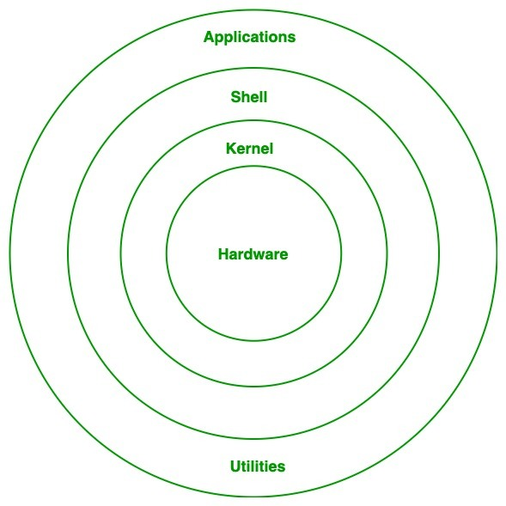

Kernel: Kernel is the core of the Linux based operating system. It virtualizes the common hardware resources of the computer to provide each process with its virtual resources. This makes the process seem as if it is the sole process running on the machine. The kernel is also responsible for preventing and mitigating conflicts between different processes. Different types of the kernel are:

* Monolithic Kernel
* Hybrid kernels
* Exo kernels
* Micro kernels
* **System Library: Is**the special types of functions that are used to implement the functionality of the operating system.
* **Shell:**It is an interface to the kernel which hides the complexity of the kernel’s functions from the users. It takes commands from the user and executes the kernel’s functions.
* **Hardware Layer:**This layer consists all peripheral devices like RAM/ HDD/ CPU etc.
* **System Utility:**It provides the functionalities of an operating system to the user.

**Advantages of Linux**

* The main advantage of Linux, is it is an open-source operating system. This means the source code is easily available for everyone and you are allowed to contribute, modify and distribute the code to anyone without any permissions.
* In terms of security, Linux is more secure than any other operating system. It does not mean that Linux is 100 percent secure it has some malware for it but is less vulnerable than any other operating system. So, it does not require any anti-virus software.
* The software updates in Linux are easy and frequent.
* Various Linux distributions are available so that you can use them according to your requirements or according to your taste.
* Linux is freely available to use on the internet.
* It has large community support.
* It provides high stability. It rarely slows down or freezes and there is no need to reboot it after a short time.
* It maintain the privacy of the user.
* The performance of the Linux system is much higher than other operating systems. It allows a large number of people to work at the same time and it handles them efficiently.
* It is network friendly.
* The flexibility of Linux is high. There is no need to install a complete Linux suit; you are allowed to install only required components.
* Linux is compatible with a large number of file formats.
* It is fast and easy to install from the web. It can also install on any hardware even on your old computer system.
* It performs all tasks properly even if it has limited space on the hard disk.

**Disadvantages of Linux**

* It is not very user-friendly. So, it may be confusing for beginners.
* It has small peripheral hardware drivers as compared to windows.
* **Is There Any Difference between Linux and Ubuntu?**
* The answer is YES. The main difference between Linux and Ubuntu is Linux is the family of open-source operating systems which is based on Linux kernel, whereas Ubuntu is a free open-source operating system and the Linux distribution which is based on Debian. Or in other words, Linux is the core system and Ubuntu is the distribution of Linux. Linux is developed by Linus Torvalds and released in 1991 and Ubuntu is developed by Canonical Ltd. and released in 2004.
* **FILESYSTEM HIERARCHY SYSTEM**
* **Linux uses single rooted, inverted tree like file system hierarchy**
* **/** This is top level directory

It is parent directory for all other directories

It is called as ROOT directory

It is represented by forward slash (/)

C:\of windows

* **/root** it is home directory for root user (super user)

It provides working environment for root user

C:\Documents and Settings\Administrator

* **/home** it is home directory for other users

It provide working environment for other users (other than root)

c:\Documents and Settings\username

* **/boot** it contains bootable files for Linux

Like vmlinuz (kernel)..... ntoskrnl

Initrd (INITial Ram Disk)and

GRUB (GRand Unified Boot loader).... boot.ini, ntldr

* **/etc** it contains all configuration files

Like /etc/passwd..... User info

/etc/resolv.conf... Preferred DNS

/etc/dhcpd.conf.... DHCP server

C:\windows\system32\dirvers\

* **/usr** by default soft wares are installed in /usr directory

(UNIX Sharable Resources)

c:\program files

* **/opt** It is optional directory for /usr

It contains third party softwares

c:\program files

* **/bin** it contains commands used by all users

(Binary files)

* **/sbin** it contains commands used by only Super User (root)

(Super user's binary files)

* Linux is case sensitive operating system
* All the commands in linux are in lowercase
* To see all the commands starting with any letter

$ x <tab> <tab>

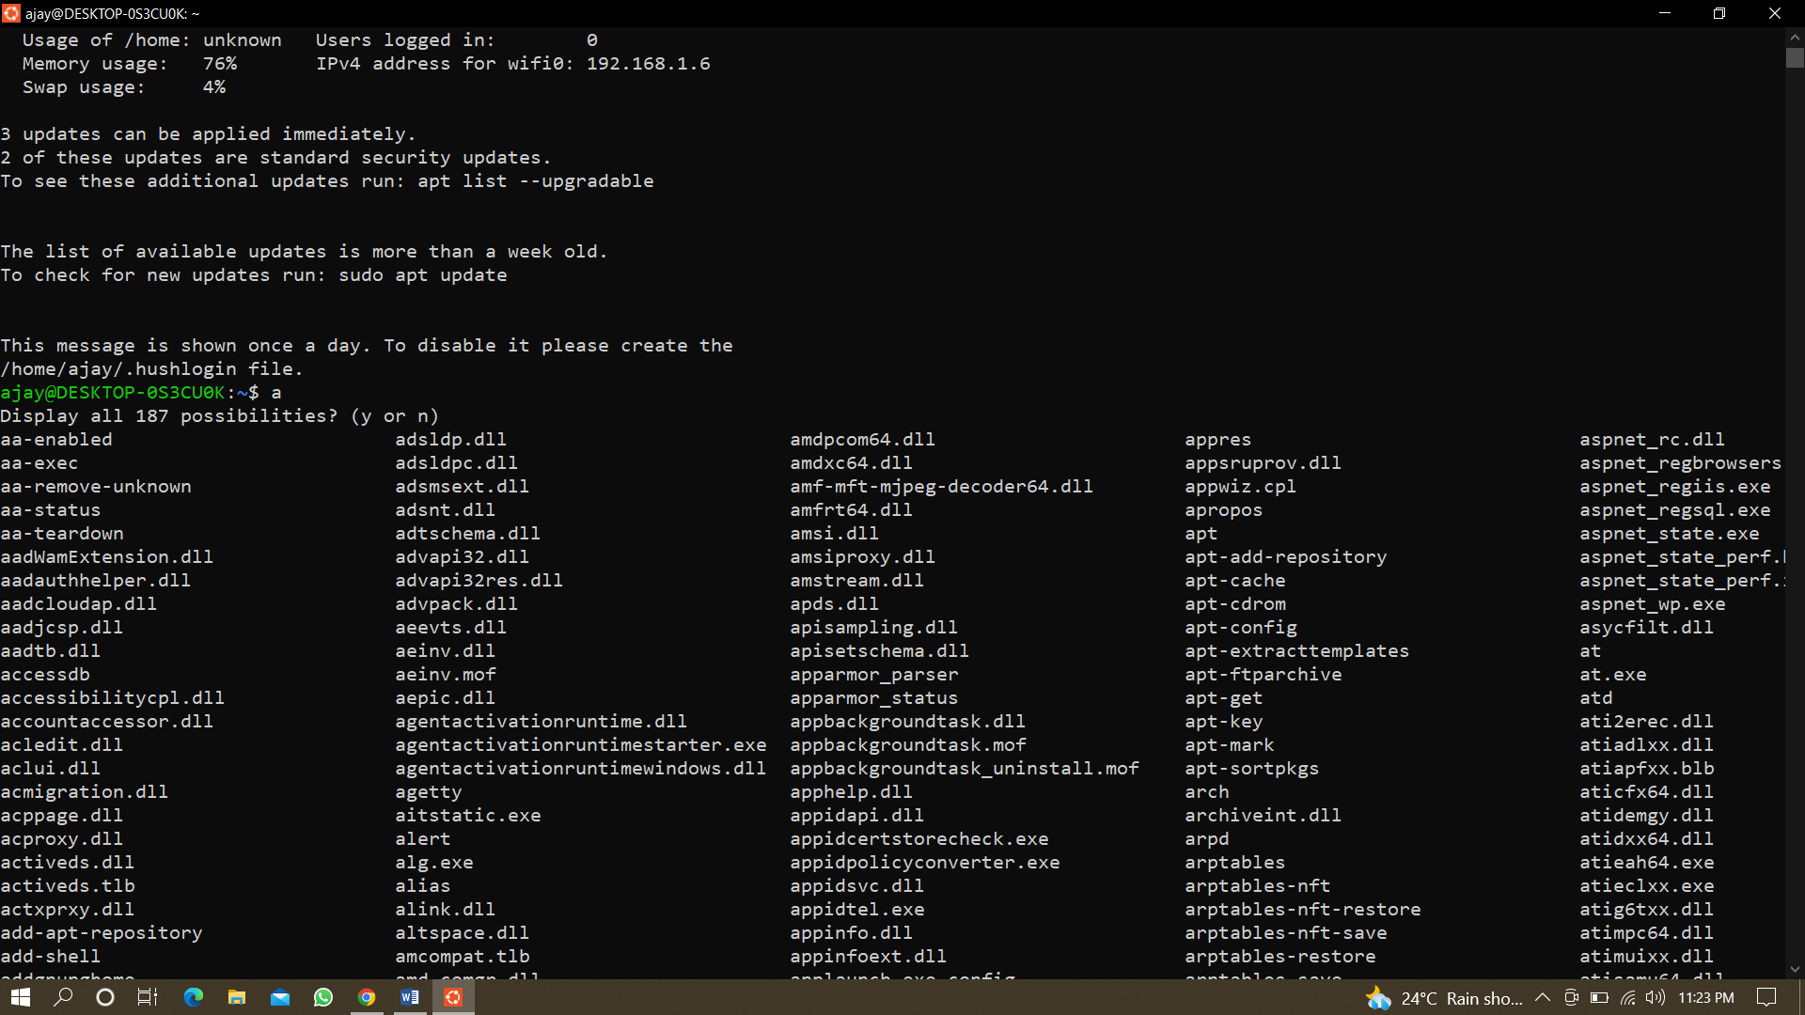

* To know about commands

$ man <command>

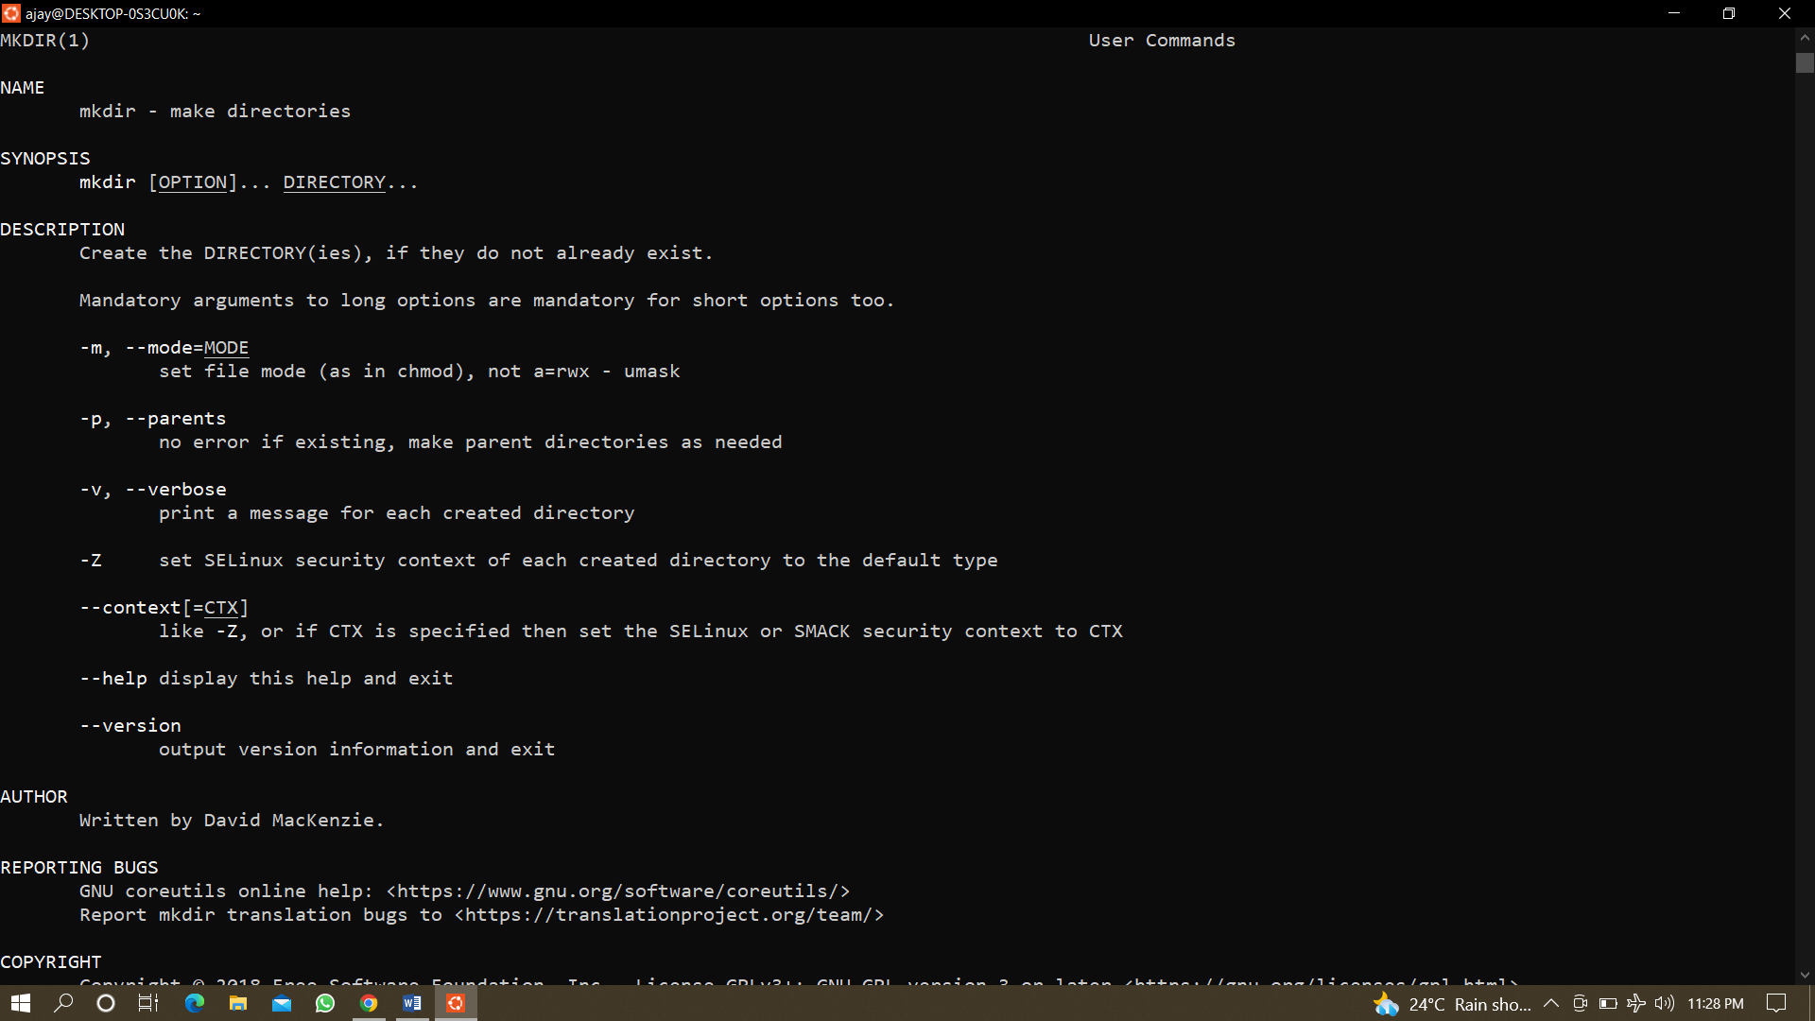

$info <command>

$mkdir –-help

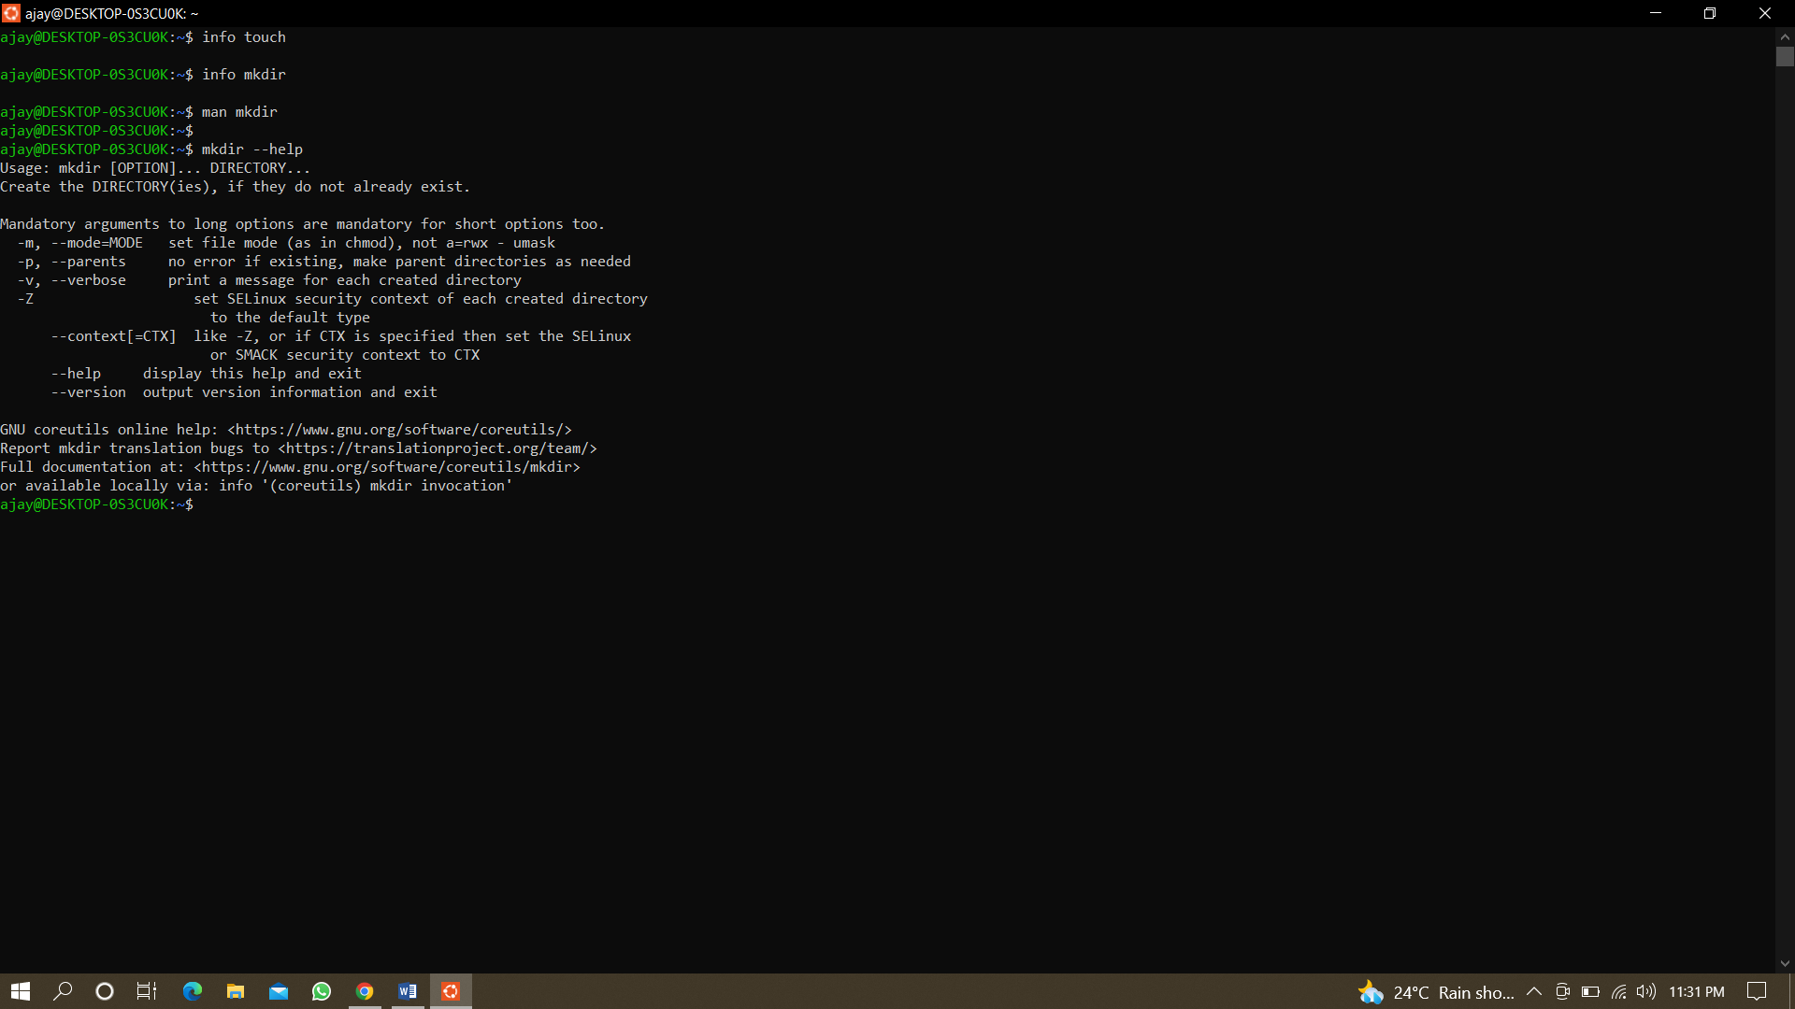

* To create a directory

$mkdir <name of directory>

Example: $ mkdir Ajay

* To create multiple directories

$mkdir <dn1> <dn2> <dn3> #dn = directory name

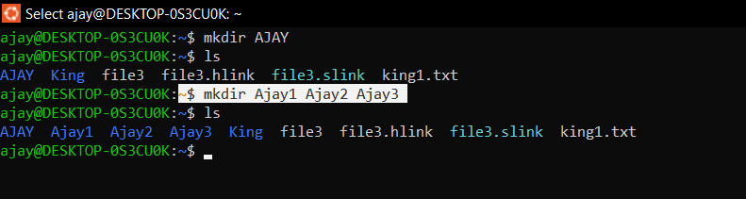

* To create 10 directories at once

$mkdir d{1..10}

* + 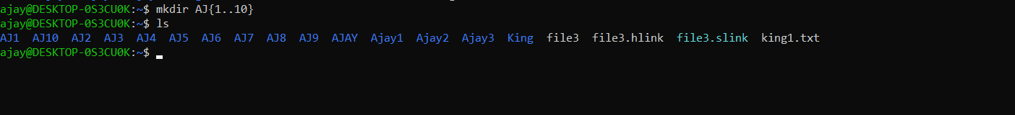
* To create Parent and child directory at once

$mkdir –p parentdir/childdir

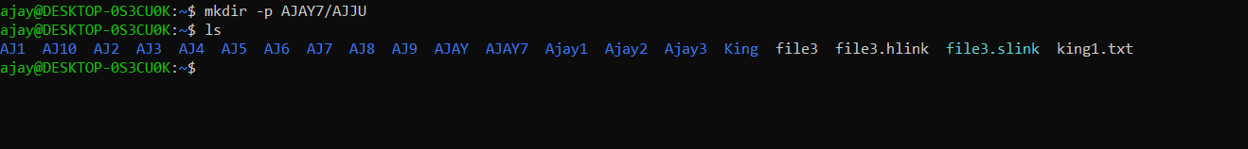

* **-v or –verbose**: It displays a message for every directory created.[directories]

**Syntax:**

**$mkdir –v [directories]**

* **-m**: This option is used to set the file modes, i.e. permissions, etc. for the created directories. The syntax of the mode is the same as the **chmod** command.

**Syntax:**

**$mkdir –m a=rwx [directories]**

* The above syntax specifies that the directories created give access to all the users to read from, write to and execute the contents of the created directories. You can use ‘a=r’ to only allow all the users to read from the directories and so on.



* Using numeric values

$ mkdir -m 777 [directory]

* Create the directory at desired location

$ mkdir [path]

$mkdir /tmp/examples

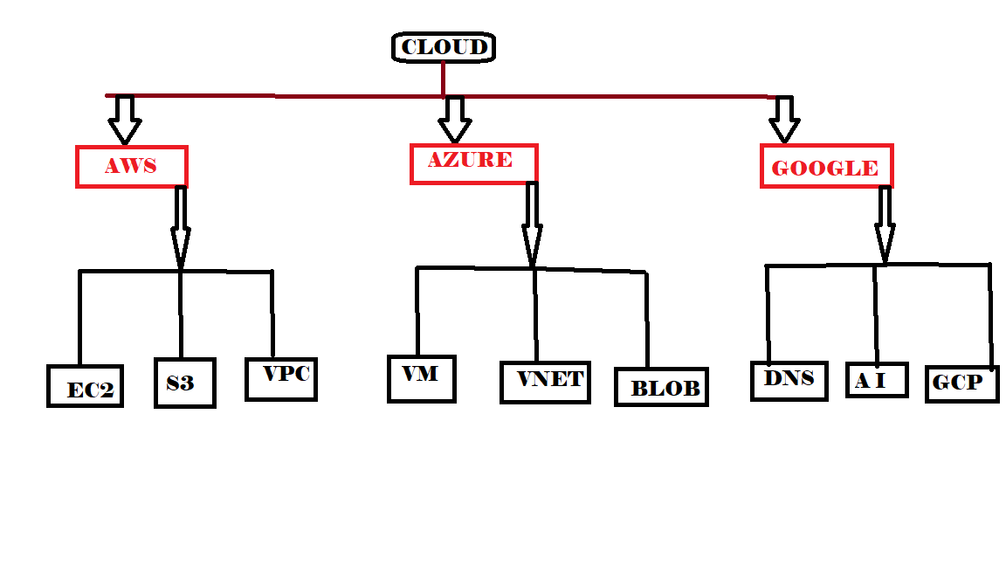

* To create above shown directory with single command :

$mkdir –p cloud/{aws/{Ec2,s3,vpc},azure/{vm,vnet,blob},google/{dns,Ai,gcp}}

COMMAND IMAGE ON NEXT PAGE



TO SEE OUTPUT OF ABOVE TREE DIRECTORY

$ tree cloud

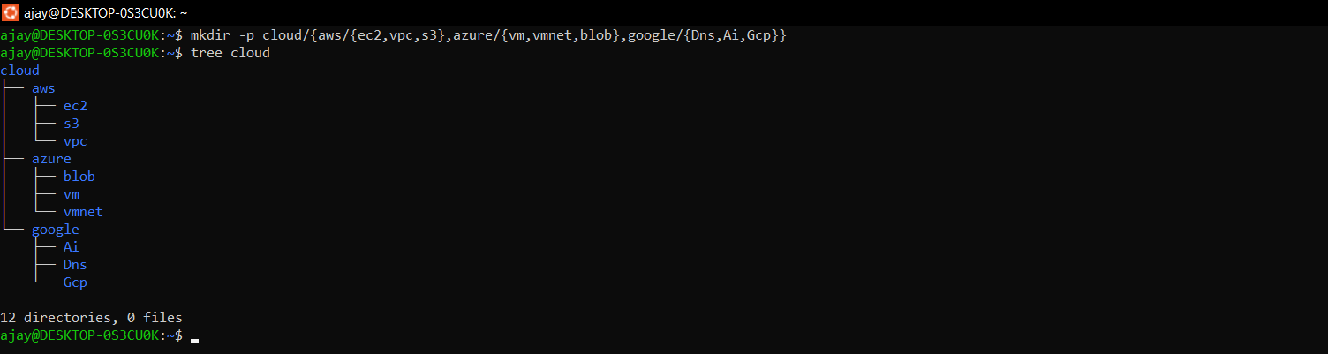

PWD COMMAND IN LINUX:

PWD means present working directory. It prints the path of the working directory, starting from the root.  
pwd is shell built-in command(pwd) or an actual binary(/bin/pwd).  
$PWD is an [environment variable](https://www.geeksforgeeks.org/environment-variables-in-linux-unix/) which stores the path of the current directory.  
This command has two flags.

$pwd –L :prints the symbolic path

$pwd –P :prints the actual path

The $PWD variable value is same as pwd -L.

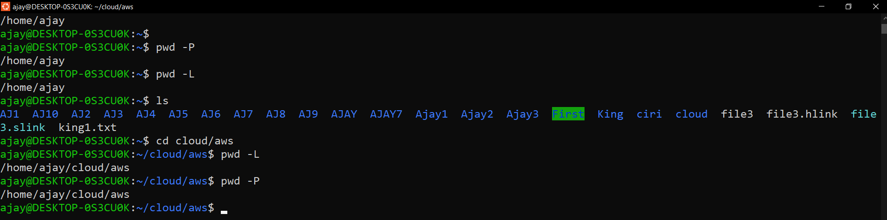

***-P****: Prints the actual path.*

**Creating a file in Linux**

**Using cat command:**

* cat (Concatenate) command is used to create a file and to display and modify the contents of a file.
* **To create a file**

**# cat > filename (say Ajayfile)**

Hello World

**Ctrl+d (To save the file)**

[ ajay@desktop-0s3cu0k] # cat > Ajayfile

Hello World

* **To display the content of the file**

# cat filename (say Ajayfile)

[ ajay@desktop-0s3cu0k] # cat Ajayfile

Hello world

**To append the data in the already existing file**

**# cat >> <filename>**

**# cat >> Ajayfile**

**Ctrl+d** (to save the changes)

[ ajay@desktop-0s3cu0k] # cat >> Ajayfile

Welcome to Linux

**Creating multiple files at same time using touch command**

**#touch <filename> <filename> <filename>**

**#touch file1 file2 file3**

[ ajay@desktop-0s3cu0k] # touch file1 file2 file3

[ ajay@desktop-0s3cu0k] # Is

file1

file2

file3

Note: to check the files use **# ls** command

**Creating a Directory:**

**#mkdir <dir name>**

**#mkdir Ajay**

[ ajay@desktop-0s3cu0k] #mkdir Ajay

[ ajay@desktop-0s3cu0k] #ls

Ajay file1 file2 file3

**Copying files into directory**

**#cp <source filename> <destination directory in which to paste the file>**

**#cp file1 Ajay**

[ ajay@desktop-0s3cu0k]# cp file1 Ajay

[ ajay@desktop-0s3cu0k]# cd Ajay

[ ajay@desktop-0s3cu0k]# ls -a

**. .. file1**

**Copying directories from one location to other**

**# cp –rvfp <dir name> <destination name>**

**#cp –rvfp Aj2 Ajay**

[ ajay@desktop-0s3cu0k]